

Technical Specification Document
NAVITAS PTE LTD

Author: [Jeeva. S]
Date: [2nd October, 2015]
Version: [1.0]

Document Control
Author
Position | Name | Contact no
 | Jeeva. S

Table of Contents
1. INTRODUCTION 4
1.1 Objectives 4
1.2 Scope 4
1.3 Development Environment 4
2. ARCHITECTURE DESIGN 5
3. PROCESS FLOW 5
3.1 Bill to Client 5
3.2 Reimbursement to Member 6
3.3 Invoice to Provider 6
3.4 Payment to provider 6
4. VALIDATIONS 7
4.1 Bill to Client 7
4.2 Reimbursement to Member 7
4.3 Invoice to Provider 7
4.4 Payment to Provider 8
4.4 Field Matrix 8
5. DESIGN 9
Data Dictionary 9
6. SOURCE CODE 11

1. INTRODUCTION

1.1 Objectives
This document is a generic technical design document for the projects. It provides guidance which is intended to assist the relevant management, technical staff or client. It is also useful background reading for anyone involved in customization or monitoring the Navitas integration interface.

1.2 Scope
This preface describes:
- Design excel template file for passing some valid inputs for respective interface in “.xls” file format.
- The four interface file name should contain as follows.
  - Bill to Client - EntityCode_AR_DDMMYYYY.xls
  - Reimbursement to Member - EntityCode_PM_DDMMYYYY.xls
  - AP Invoice to Provider - EntityCode_AP_DDMMYYYY.xls
  - Payment to provider - EntityCode_PP_DDMMYYYY.xls
- Create the mapping table (Non object) in SAP B1, containing information about the database initial settings for the creation of respective documents.
- Create the mapping table (Non object) in SAP B1, which contains information about the item codes for the respective interface.
- Create the required user defined fields in marketing documents and in payment documents.
- While running the interface program, the program identifies the respective excel file and import the values in the data view
- Get the data`s for respective reference and start doing the validation
  - Validating whether item code has corresponding values in Item code mapping table.
  - Validating whether G/L account, Cost Centre available in SAP or not.
  - Validating payment mode, ID for Reimbursement to member and payment to provider interface.
- Any one of this validation fails, the system should prompt some related information's, so that the user get notified.
- If it`s not fails, the system will post the respective transaction in SAP B1.

1.3 Development Environment
- This Solution is a true Console application, Developed in VS2010 with using SAP B1 9 DLLs.

IDE: Visual Studio 2010
.Net Framework: 3.5
SAP Components: SAP B1 DIAPI

2. ARCHITECTURE DESIGN

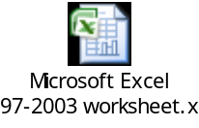

Connect Target Company
Respective SAP B1 Documents

It will process the excel sheet one by one, followed by validation. Once the validations are completed, It will generate the respective documents in SAP B1.

Business Logic

SQL Server (DB)

3. PROCESS FLOW

- The user has to make sure that all the excel sheets should be in “.xls” format and before starting the integration the excel sheets should be closed.
- All the required data’s should be filled by the user in the company user defined table and item code mapping table.
- User has to check whether the values in configuration file are correct before starting the integration.
- The program reads the excel sheet file name in the input folder of the specified path in alphabetical order and the corresponding documents will be created.
- The file name with the corresponding documents creation is as below
  - If the file name contains “_AR_” then A/R Invoice or A/R Credit memo document will be created.
  - If the file name contains “_PM_” then Outgoing payment on account based will be created.
  - If the file name contains “_AP_” then A/P Invoice or A/P Credit memo document will be created.
  - If the file name contains “_PP_” then Outgoing payment on customer based will be created.

3.1 Bill to Client
- The program reads the file from the respective input folder with file name which contains “_AR_” into a data view and connects to the company that is specified in the excel sheet.
- If the company connection is established not success then an error message will be written in the log file and the program terminates.
- If the company connection is successful then the programs check the gross total value in the excel sheet to determine whether an A/R Invoice or A/R Credit memo to be created.
- If the gross total value is positive then A/R invoice will be created else if negative then A/R Credit Memo document will be created.
- The program initially check the “Medical claim” column and “TPA-FFS” column in the excel sheet.
- If any of the both column contains value greater than zero then the excel sheet is considered as Bill to client Panel else Non Panel.
- After determining the bill to client sheet type the required validations will be checked.
- If the validation is succeeded then the corresponding document will be created.
- If the integration of the excel file is succeeded then a success mail will be forwarded the mail id mentioned in the configuration file and the file will be moved to the success folder or else if any error occurs during integration then a mail will be forwarded to the mail id mentioned in the configuration file with the error details and the excel file will be moved to the error folder.

3.2 Reimbursement to Member
- The program reads the file from the respective input folder which contains “_PM_” in file name into a data view and connects to the company that is specified in the excel sheet.
- If the company connection is not success then an error message will be written in the log file and the program terminates else the program tries to create outgoing payment on account basis.
- Initially the program reads all the excel values into a data view and the values are grouped based on payment mode and GIRO Id which is mentioned in the remarks column.
- If the payment mode is GIRO/CPF then a outgoing payment with bank transfer will be processed, and if the payment mode is Cheque then multiple outgoing payment with a single cheque payment mode will be processed.

3.3 Invoice to Provider
- The program reads the excel file which contains “_AP_” in the file name in the input folder into a data view and connects to the target company which is specified in the excel file.
- If the target company connection is successful, then the program checks for the reimbursement column in the data view.
- If the reimbursement column value is positive then the program creates an A/P Invoice documents else if the column values is negative then an A/P Credit memo document will be generated.
- The program groups the data view column based on the business partner code in the excel sheet.
- The program checks for the business partner code in SAP. If the business partner code doesn’t exist then the program creates the business partner and a set of validations will be processed.
- If the validation is success then an A/P Invoice or A/P Credit memo document will be generated based on the reimbursement column value.

3.4 Payment to provider
- The excel file in the input folder with file name which contains “_PP_” are processed into a data view and connects to the target company which is specified in the file.
- The data’s in the data view are grouped based on the payment mode that is specified in the payment mode column and business partner code in the excel sheet.
- The program checks for the business partner code in the connected company. if the business partner code doesn’t exist in the connected company the program creates a new business partner code.
- After grouping the program calculates the total payment value based on the reimbursement amount column value and creates the outgoing payment document based on the payment mode column.
- If the payment mode is GIRO/CPF then an outgoing payment document with bank transfer will be processed and if the payment mode is Cheque an outgoing payment document with cheque transfer will be processed.

4. VALIDATIONS

4.1 Bill to Client
- The A/R invoice or credit memo document will be created in this interface file. Based on the gross total value in the excel sheet the invoice and credit memo document will be generated. If the gross total value is positive then Invoice document will be generated else credit memo document will be added.
- The program checks whether the card code in the excel sheet exists in the SAP business partner master. If there is no corresponding business partner found in the SAP business partner, the program should add the business partner record automatically.
- The program checks whether the cost centre code in excel sheet exists in SAP. If no corresponding record found then the program should pop up an error message to the user and no import should be made to SAP.
- The program checks whether the account code has a corresponding record in SAP. If no such records are found then the program throws an error message and the import process will be stopped.
- The programs checks whether the customer reference number for the respective document is already added in SAP. If any duplicate customer reference number is found then the program prompts an error message indicating the duplication of customer reference number and the import process gets terminated.
- Similarly the programs checks for the item code and tax code in SAP. If no such corresponding records are found then the programs will give the corresponding error message and the import process will be stopped.

4.2 Reimbursement to Member
- The programs groups the data’s based on the payment mode, GIRO ID and creates the respective outgoing payment document based on Account. If the Payment Mode is GIRO and CPF then the program creates outgoing payment with bank transfer payment mode else if payment mode is Cheque then the program creates outgoing payment with cheque payment mode.
- The program initially checks whether the excel sheet contains any row with empty payment mode. If such rows are found then it prompts an error message and the import will be stopped.
- The account code for the bank transfer will be obtained from the company datatable.

4.3 Invoice to Provider
- The excel data’s are grouped based on the vendor code and A/p invoice or A/p credit memo document will be created in this interface file based on the Reimbursement amount value in the excel sheet. If the Reimbursement amount is positive then Invoice document will be generated else credit memo document will be added.
- The program checks whether the card code in the excel sheet exists in the SAP business partner master. If there is no corresponding business partner found in the SAP business partner, the program should add the business partner record automatically.
- The program checks whether the cost centre code in excel sheet exists in SAP. If no corresponding record found then the program should pop up an error message to the user and no import should be made to SAP.
- The program checks whether the account code has a corresponding record in SAP. If no such records are found then the program throws an error message and the import process will be stopped.
- The programs checks whether the customer reference number for the respective document is already added in SAP. If any duplicate customer reference number is found then the program prompts an error message indicating the duplication of customer reference number and the import process gets terminated.
- Similarly the programs checks for the item code and tax code in SAP. If no such corresponding records are found then the programs will give the corresponding error message and the import process will be stopped.

4.4 Payment to Provider
- The program group the excel data’s based on the payment mode and customer code and creates outgoing payment based on customer.
- The payment mode is determined based on the payment mode in the excel sheet. If the payment mode is GIRO/CPF then bank transfer is done else if the payment mode is Cheque then cheque payment is processed.
- Payment method is mandatory and should be mentioned in excel sheet. If the program detects any row with empty payment mode it prompts a error message and the import process gets terminated.
- Initially it checks whether the business partner codes exists in SAP, If not then the program creates the business partner master data with the respective information.
- The program first calculates the total amount based on the customer code and adds the outgoing payment document invoices based on a sequence method.

4.4 Field Matrix
A User Defined Tables (UDT) with no object has been created in SAP Business One under the company IHP (IHP_LIVE database) .This table contains the credentials for other databases for the integration file to log in into the target database and also it contains the other relevant data’s.

UDT Name: dbo.[@AI_TB01_COMPANYDATA]
UDF COLUMN | COLUMN DESCRIPTION | REMARKS
Code | Database Code
Name | Database Name
U_DATABASE | Database description | Database description
U_SAPUSER | Database user id | Database Log in User id
U_SAPPASSWORD | Database password | Database login password
U_CheckGLAccount | G/L Account | Account code for Check payment
U_CheckBankAccount | House bank account | Account code for check payment
U_CheckBankCode | House bank account bank code
U_GIROGLAccount | G/L Account | Account Code for bank transfer payment
U_CheckBankCountry | Bank Country Code | Bank Code for the Check payment
User needs to provide the relevant datas during design stage. After go-live, user will have to maintain this table.

Tools → User-Defined Windows → AB_TB01_COMPANYDATA – COMPANY DATAS

UDT Name: dbo.[@AE_ITEMCODEMAPPING]
UDF COLUMN | COLUMN DESCRIPTION
Code | Item Code
Name | Item Description

User needs to provide the relevant datas during design stage. After go-live, user will have to maintain this table.

Tools → User-Defined Windows → AE_ITEMCODEMAPPING – ITEM CODE MAPPING

5. DESIGN

Data Dictionary
Descriptions of all the fields and Tables in the system.
A User Defined Tables (UDT) with no object has been created in SAP Business One under the company IHP (IHP_LIVE database) .This table contains the credentials for other databases for the integration file to log in into the target database and also it contains the other relevant data’s.

UDT Name: dbo.[@AI_TB01_COMPANYDATA]

UDF Details
- DATABASE Alphanumeric(100)
- SAPUSER Alphanumeric(50)
- SAPPASSWORD Alphanumeric(10)
- CheckGLAccount Alphanumeric(20)
- CheckBankAccount Alphanumeric(20)
- CheckBankCode Alphanumeric(20)
- GIROGLAccount Alphanumeric(20)
- CheckBankCountry Alphanumeric(50)
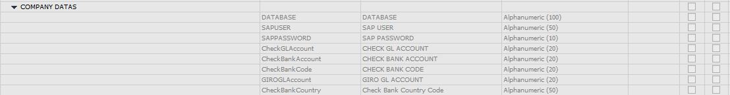

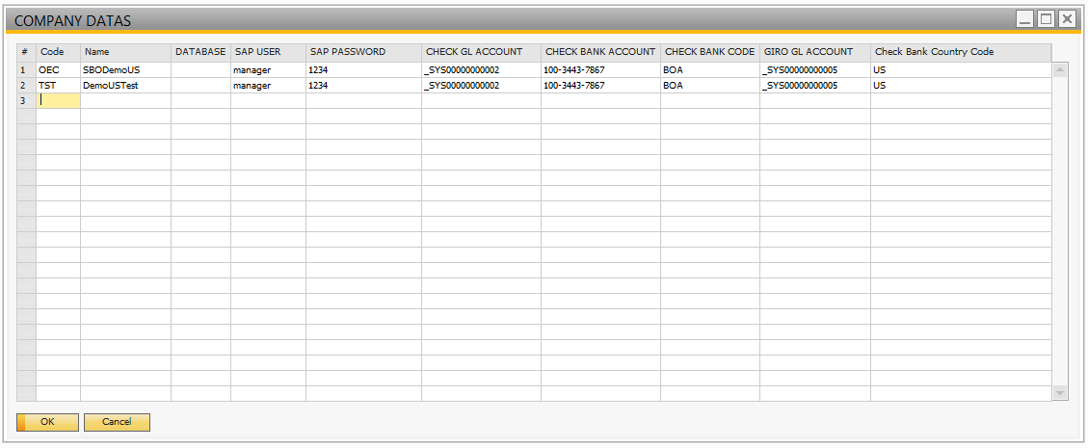
UDT Name: AE_ITEMCODEMAPPING

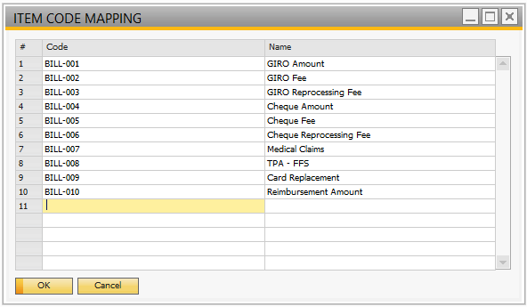

User defined columns in Marketing Document

UDF Fields
- AI_APARUploadName Alphanumeric(250)
- AI_BatchNo Alphanumeric(50)
- AI_InvRefNo Alphanumeric(50)

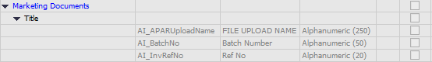

User Defined Columns in Payment Document

UDF Fields
- AI_APARUploadName Alphanumeric(250)
- AI_CustName Alphanumeric(100)
- AI_CustCode Alphanumeric(20)
- AI_PayMode Alphanumeric(100)
- AI_PayeeAcNo Alphanumeric(100)

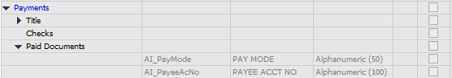

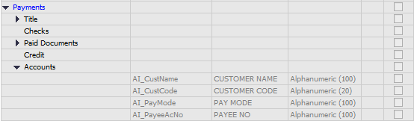

SOURCE CODE

The SVN link to download the source code is as below:

https://github.com/abeob1/sg-ae-navitas/trunk

